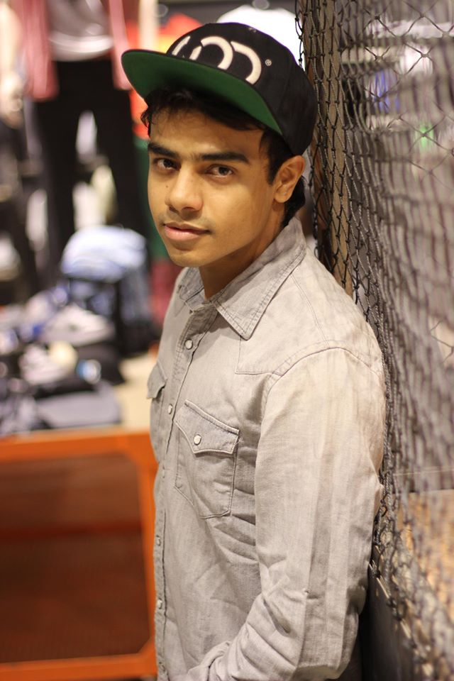 | Sandeep Chhabra  Chhabra.sandeep2811@gmail.com  # +91-9999510557  D.O.B. - 28th November 1987

Objective –

To grow professionally and personally by exploring dance in every way possible and to utilize my skills to the best to promote a healthy dance culture in my country.

Training –

> Trained in Philippines in Lyrical & New School Hip Hop from the world renowned teachers / performers / choreographers like - Phillip Chbeeb (I Am ME – USA), Di Moon (I Am ME – USA), Brian Puspos (Mos Wanted Crew – USA), April Rodriguez, Chachi Gonzales (I Am ME – USA), Aye Hasegawa, Fanny Pak, Dumbo (Poreotics), etc.

> Have been training in various dance styles like Jazz, Contemporary, Ballet in India

Dance Credentials/Accomplishments –

> Hip Hop solo Winner at national level event held in Mumbai “Artists In Action’’ https://www.youtube.com/watch?v=5o-pfQVj_fU

> Organised one of the best Dance Tour in India “Urban Dance Tour India’’ featuring CHACHI GONZALES from USA. https://www.facebook.com/UrbanDanceTourIndia

> Travelled and Performed with “Yo Yo Honey Singh” as Dance Artist to Dubai, Malaysia, Mumbai & Pune.
https://www.youtube.com/watch?v=Vo44j0BTzww

> Got featured in a Music Video of “Yo Yo Honey Singh” - Kisse Kehte Hai Hip Hop.
https://www.youtube.com/watch?v=uaCYeQ9FtSI

> Featured in a online advertisemt of “TATA NANO”

> Winner of KPOP Contest India 2014 as part of “Urban Age Crew”
https://www.youtube.com/watch?v=hflSBpUrrAg

> Is a part of an elite Hip Hop Dance Company “Limited Edition”, based in Philippines.
http://www.youtube.com/watch?v=Ax9MpSsY-BM

- Was assistant choreographer to Mr. Rajiv Surti for the most popular dance reality show in India, Dance India Dance.
http://www.youtube.com/watch?v=sqyX4xoT0ho

- Performed for and assisted choreography for an upcoming Bollywood movie “I, Me and Myself”.

- Assisted choreography of an international brand - Allen Solly’s advertisement.
http://www.youtube.com/watch?v=3O_OIZPLs5s

- Choreographed and performed for various Company Hip Hop performances with Big Dance Centre.
http://www.youtube.com/watch?v=MhgE41xjSmQ

- Have worked with several non-profit organizations like Navjyoti India Foundation and India Vision Foundation.

- Choreographed for various colleges in Delhi, which have won accolades and awards in various inter-collegiate competitions.

- Have won various national and inter-collegiate level dance competitions in group and as a solo performer.

